Casselton Summerfest Committee
Wednesday, December 13th 2023
5:30PM Red Baron

In attendance: Cami Wack, Nikki Geist, Cecelia Jorud, Alisha Ausk.

The agenda for this meeting is listed here by day. Items are being delegated to committee members and bolded.
Thursday
*Alisha will verify these events are the same time and location.
- Note: Swanks runs this day and all events that occur
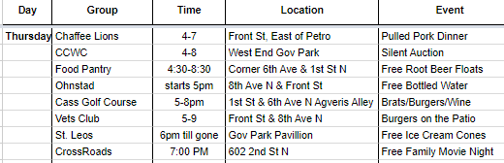
Friday
*Cecelia will verify with the Park Board at their next meeting on January 10th at the Casselton Golf Course Clubhouse at 5pm.
1. Find out from Cami what size space the foam party needs
2. Ask local bars if there is any interest in setting up a beer bath at the park area of the pool approximately 1-8pm.
3. Ask Parks about using a space near the pool for the foam party.
4. Ask parks for permission to allow bars to sell booze on the property Friday (they also have a liquor license and might want to sell drinks, they will also need an offsite permit $10) approximately 1-8pm.
5. Suggest to the Presbyterian Church to move their ice cream event to the pavilion at Governor’s Park and change the time to 4-7pm

*Cami will contact Bubble Bonanza and book them for Friday 3-6pm, also find out their final cost and how much space is needed. Then update Cecelia ASAP.

- Motion to request Open Swim on Friday & Saturday with Parks & Rec
  - When: Friday 1-5pm & 7-9pm, Saturday 1-5pm
  - Note: Need to attend Park Board Meeting for approval
- Motion to have Foam Party
  - Cost: TBD
  - Location: By the Pool
  - When: Friday 2-5pm
- Motion to ask if local businesses would like to partner on a Beer Garden
  - Cost: TBD
  - Who:
    - Local bars to handle beer: Offsite Permit Needed
    - 4e Winery to provide wine: Alcohol Sales Permit Needed
  - When: Friday 1 – 8pm (TBD)
- Motion to ask if Presbyterian Church would move their Friday Ice Cream event to Governors Park
  - Why: Centralizes food on Friday afternoon/Evening to one location & closer to the pool activities
  - Time: Ask if they will move from 5-6:30pm to 4-7pm
- Note:
  - Need to list cost for the Variety Show entry fee in 2024
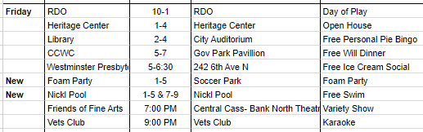
Saturday
*Alisha will verify with the Caricature Artist, Alyssa, the final cost and if she would like to attend from 3-7pm near Trucore. | Verify with Rusty K Ranch about train noise and explain they will have 2 sides of the area fenced. There will also be a parade from 11-12pm, they can set up the day before. If they are ok with this, hire them. | ASP from 10:30-4pm – book them. | Sheriff Deputy from 8-12pm – hire them.

*Cami will verify the bouncy house agreement and get final pricing.

*Nikki will reach out to the face painter in Amenia and see if she would like to be at Summerfest again, but as a paid artist offering free services.

- Motion to hire a Caricature “Cartoon Artist”
  - Cost $120/Hr & $0.60/Mile
  - When: Saturday
  - Where: By TruCore (Cecelia has extra white tent for shade)
  - Requires 3 chairs & shaded area
- Motion to hire a Face Painter
  - Who?
    - Hopscotch: $540 for 4 Hours
    - Painted Turtle (Used Last Year)
  - Location: By TruCore
  - When: Saturday
- Motion to hire Bouncy Houses
  - Cost $2,880 approx.
  - Location: Same as 2023, by Vets Club
  - When: Saturday
- Motion to have Petting Zoo
  - Cost: $300 1st Hr, $100 Every Hour following
  - Location: By the Vets Club, after the Bouncy Houses
  - When: Saturday
- Motion to have 2 ASP Staff for Parade
  - Who: 2 ASP Staff Members
  - Location:
    - 18th by the School & 1st St/Langer (11AM to End of Parade)
    - Move to 6th/1st (Immediately after parade to 4pm)
  - When: 11am to 4pm
- Motion to have Sheriff Deputy for safety and traffic control for Street Dance
  - Who: Deputy Sheriff
  - Location: Surrounding area of Governors Park
  - Cost: $60/Hour – 4 Hr Minimum
  - When: Saturday, Time TBD
- Note:
  - Street Dance Questions:
    - What does the band need for size platform?
    - Block off the Car Doctor with stage/trailers?
    - Spools placed in 6th St, what time would they need to be moved by?
    - Bleachers placement?
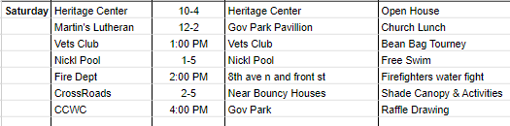
Sunday
*Cami will verify at next PTA meeting that they would like to partner in the 5k as a fundraiser
*Cecelia will connect with SB&B about the fun run/color run and partnering with the PTA.
*Nikki will verify with Laif Rognlin about the First Responders Picnic.

- Motion to have 5K
  - Who?
  - Location: Tinta Tawa Park (Start & Finish)
  - When: Request to change Kids Run from Saturday morning to Sunday morning and align both Kids Run and 5K.
- Motion to set expectations for Boy Scouts cleaning up on Sunday morning
  - Define Expectations
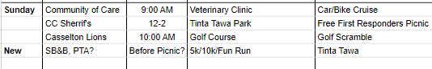
Public Works / City Approval Needed:

Invite Kevin and Will once items are in place to let them know exactly what is needed and when.
- Road Closures
- ASP
- Water Source
- When to get approval with this team?

2025 Summerfest

This option is not currently in play – Nikki has reached out and nobody has replied. We will continue to try.
- Motion to have Lieutenant Dan Band for 2025 and attempt to get a contract signed ASAP

Meeting adjourned 7:00pm
Next meeting is January 23, 2024 at Dusty’s Bar & Grill (Club 94 as a secondary option if Dusty’s isn’t open yet)

Respectfully Submitted

Nikki Geist
Summerfest Vice President

Nikki’s notes for next meeting.
- Order Porta potties and choose placement
- Tent sizes and placement
- Expectations for Boy Scouts and any other group that would like to help. Once we finalize tasks, we will create a list.
- Update website with PO Box 548 for Casselton Summerfest
- Look for past financials in the Summerfest folders at City Hall in the CBA closet, possible meeting in chambers to go over these as a committee.

